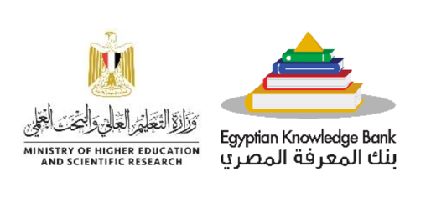

Subject: Join Our Awareness Session on European Funding Opportunities – Part of a Workshop Series organized by EKB
Dear Colleagues,

We are excited to invite you to our next awareness session on European funding opportunities for researchers’ mobility and staff exchange, organized as part of an ongoing workshop series that we announced before. This event, brought to you by the Egyptian Knowledge Bank (EKB) and the Centre for Innovation and Technology Development (ECITD). This session will start with a general overview of the EU funding landscape for research and innovation within the framework of Horizon Europe programme, followed by a more specific focus on current and next opportunities under MSCA programme. MSCA includes funding for career development, researchers’ mobility, doctoral programs, doctoral networks and staff exchange. The session will also offer practical tips on how to develop a successful proposal and will provide information on where to find support.

Event Details:
Title: European Funding Opportunities for Staff Exchange, Training, Research and Networking opportunities [Awareness Session]
Date: September 14, 2024
Time: 06:00 PM Cairo Time
Platform: Zoom

This session is part of a series of workshops to enhance researchers' knowledge and access to international competitive funding avenues.

To participate, please register in advance using the following link:
[Register for the Zoom Webinar] https://us02web.zoom.us/webinar/register/WN__8EHIT3QTPWsFfYF5sN9Sw

Upon registration, you will receive a confirmation email with details on how to join the meeting.

We look forward to your participation and hope this workshop will be a valuable resource for advancing your research goals.

For further communication please contact Ms. Salma Essawi, Head of operation at ECITD , salma.essawi@ecitd.org

Best regards,

Dr. Ola Lowrance
Egyptian Knowledge Bank (EKB)
Dr. Amr Radwan
EU Egypt National Contact Point for Horizon Europe-MSCA and European Innovation Council

